- Write Three Address Code for the following expression-all three types.
-(a x b) + (c + d) – (a + b + c + d)
(1) T1 = a x b
(2) T2 = uminus T1
(3) T3 = c + d
(4) T4 = T2 + T3
(5) T5 = a + b
(6) T6 = T3 + T5
(7) T7 = T4 – T6

- Write Three Address Code for the following expression-
If A < B then 1 else 0
Three Address Code for the given expression is-
(1) If (A < B) goto (4)
(2) T1 = 0
(3) goto (5)
(4) T1 = 1
(5)

- Write Three Address Code for the following expression-
If A < B and C < D then t = 1 else t = 0
Three Address Code for the given expression is-
(1) If (A < B) goto (3)
(2) goto (4)
(3) If (C < D) goto (6)
(4) t = 0
(5) goto (7)
(6) t = 1
(7)

- Translate the following expression to quadruple, triple and indirect triple-
a + b x c / e ↑ f + b x c
Three Address Code for the given expression is-

T1 = e ↑ f
T2 = b x c
T3 = T2 / T1
T4 = b x a
T5 = a + T3
T6 = T5 + T4

Quadruple Representation-

Location | Op | Arg1 | Arg2 | Result
(0) | ↑ | e | f | T1
(1) | x | b | c | T2
(2) | / | T2 | T1 | T3
(3) | x | b | a | T4
(4) | + | a | T3 | T5
(5) | + | T5 | T4 | T6

Triple Representation-

Location | Op | Arg1 | Arg2
(0) | ↑ | e | f
(1) | x | b | c
(2) | / | (1) | (0)
(3) | x | b | a
(4) | + | a | (2)
(5) | + | (4) | (3)

Indirect Triple Representation-

 | Statement
35 | (0)
36 | (1)
37 | (2)
38 | (3)
39 | (4)
40 | (5)

Location | Op | Arg1 | Arg2
(0) | ↑ | e | f
(1) | x | b | e
(2) | / | (1) | (0)
(3) | x | b | a
(4) | + | a | (2)
(5) | + | (4) | (3)

- Translate the following expression to quadruple, triple and indirect triple-
a = b x – c + b x – c
Three Address Code for the given expression is-

T1 = uminus c
T2 = b x T1
T3 = uminus c
T4 = b x T3
T5 = T2 + T4
a = T5

Now, we write the required representations-

Quadruple Representation-

Location | Op | Arg1 | Arg2 | Result
(1) | uminus | c |  | T1
(2) | x | b | T1 | T2
(3) | uminus | c |  | T3
(4) | x | b | T3 | T4
(5) | + | T2 | T4 | T5
(6) | = | T5 |  | a

Triple Representation-

Location | Op | Arg1 | Arg2
(1) | uminus | c
(2) | x | b | (1)
(3) | uminus | c
(4) | x | b | (3)
(5) | + | (2) | (4)
(6) | = | a | (5)

Indirect Triple Representation-

 | Statement
35 | (1)
36 | (2)
37 | (3)
38 | (4)
39 | (5)
40 | (6)

Location | Op | Arg1 | Arg2
(1) | uminus | c
(2) | x | b | (1)
(3) | uminus | c
(4) | x | b | (3)
(5) | + | (2) | (4)
(6) | = | a | (5)

- Translate the arithmetic expression
(a+b*c)+d+(a+b+*c)-d+e into
1 syntax tree
2 Postfix notation
3 Three address code.

Syntax Tree

Step-01:

We convert the given arithmetic expression into a postfix expression as-

( a + b ) * ( c – d ) + ( ( e / f ) * ( a + b ) )
ab+ * ( c – d ) + ( ( e / f ) * ( a + b ) )
ab+ * cd- + ( ( e / f ) * ( a + b ) )
ab+ * cd- + ( ef/ * ( a + b ) )
ab+ * cd- + ( ef/ * ab+ )
ab+ * cd- + ef/ab+*
ab+cd-* + ef/ab+*
ab+cd-*ef/ab+*+

Step-02:

We draw a syntax tree for the above postfix expression.

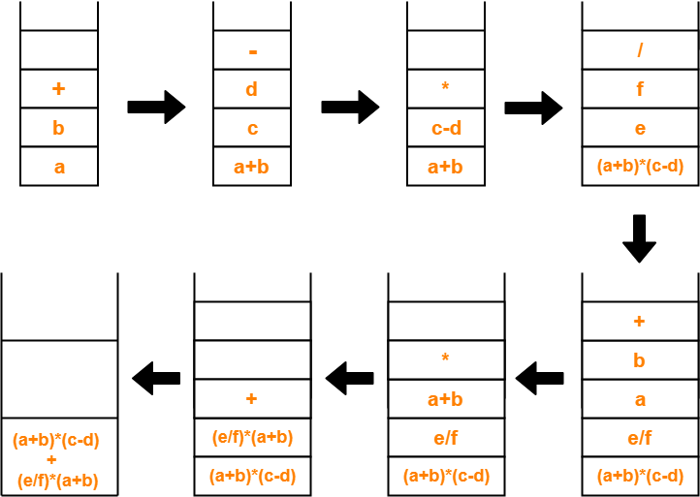

The required syntax tree is-

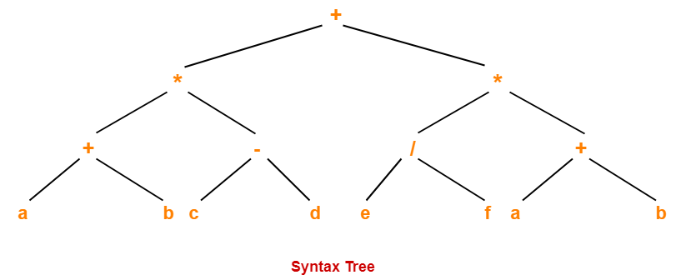

- FIND out given expression is of L attribute or S attribute
1 ) X => ABC {B.P = X.P, B.P = A.P, B.P = C.P}
This is not an L-attributed SDT because B.P = X.P and B.P = A.P are allowed, but B.P = C.P doesn’t follow the rule of L-attributed SDT definition.
2) A -> XYZ {Y.S = A.S, Y.S = X.S, Y.S = Z.S}
is not an L-attributed grammar since Y.S = A.S and Y.S = X.S are allowed but Y.S = Z.S violates the L-attributed SDT definition as attributed is inheriting the value from its right sibling.

- make DAG for following expression(SDT)
1) a + a * ( b – c ) + ( b - c ) * d

2) E→ T R
R→ addop T {print(addop)} R | ε
T→ num {print(num)}
parse tree for 9 – 5 + 2

3) S → A₁ A₂ {A₁.in = 1,A₂.in = 2}
A → a {print(A.in)}

4) E → E₁ + T E.val := E₁.val + T.val
E → E₁ – T E.val := E₁.val – T.val
E → T E.val := T.val
T → (E) T.val := E.val
T → num T.val := num.lexval

